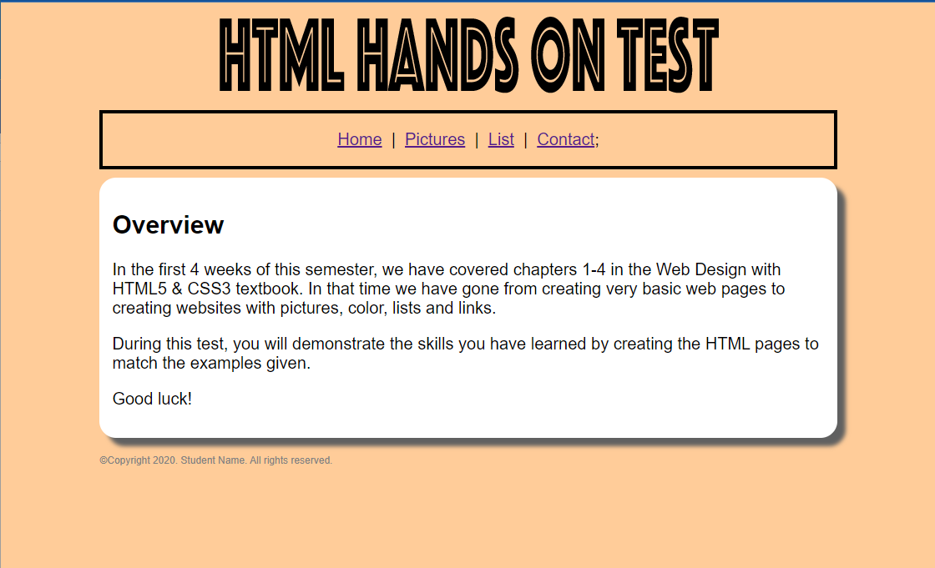 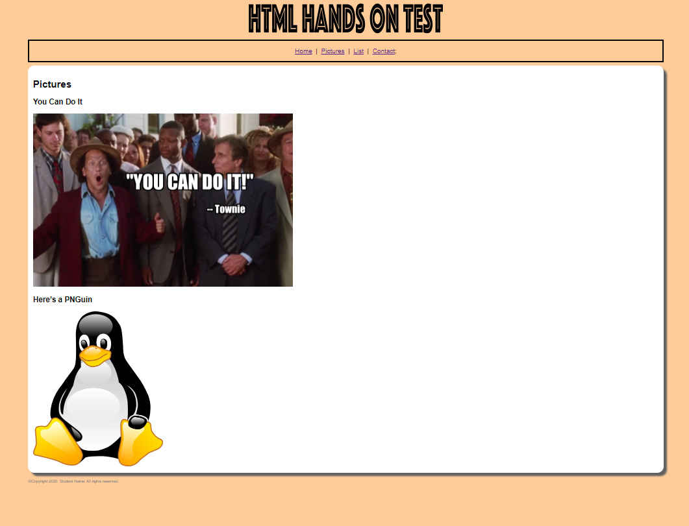

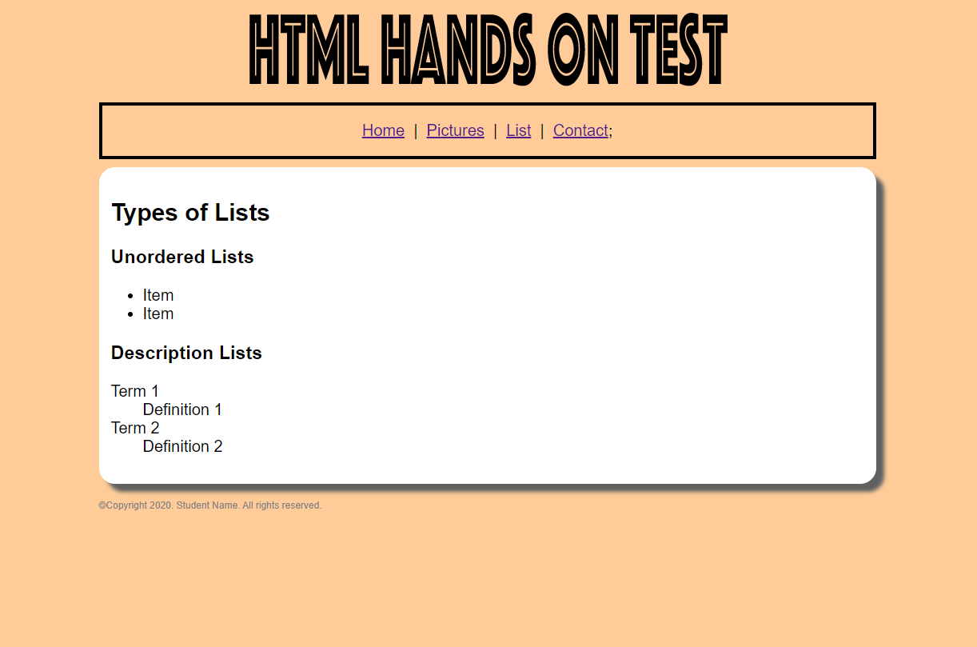 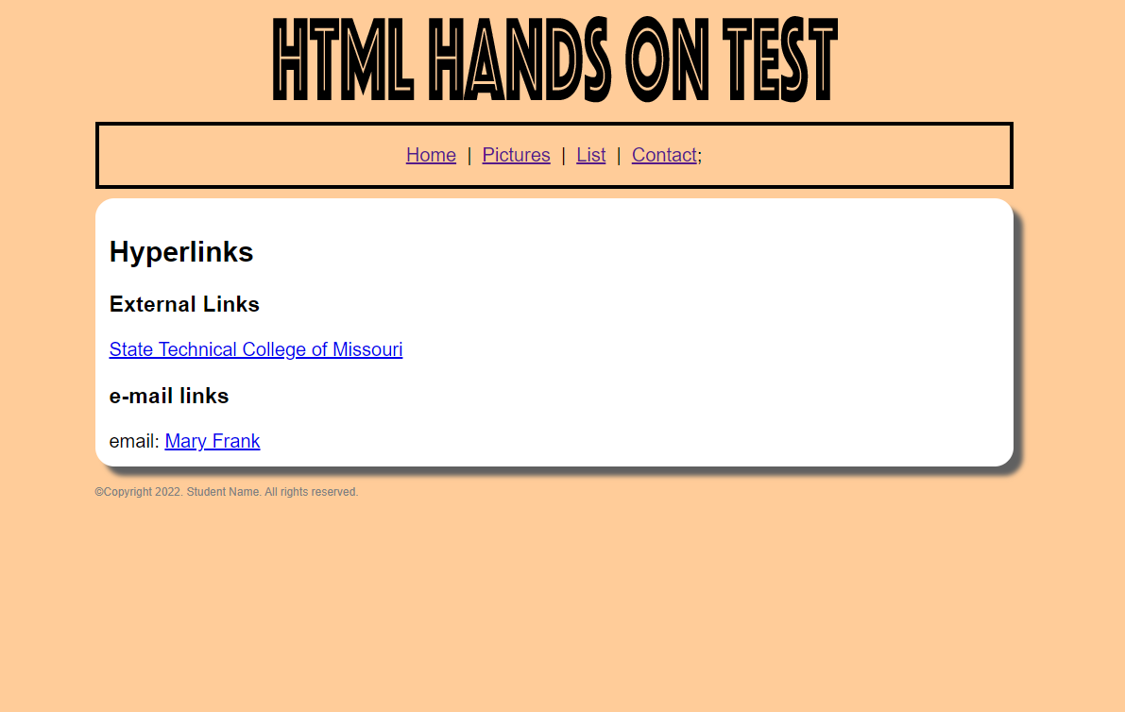

1. Using the included template.html and images above as reference you will create 4 additional HTML pages:
   1. index.html
   2. pictures.html
   3. lists.html
   4. contact.html
2. You will need to link the external CSS file (styles.css) to all four HTML files.
3. Notes for ALL pages:
   1. All pages should follow the same layout as the template page
   2. All headers should display the test.png image
   3. All <nav> sections should have links to all other pages
   4. Use the <main> section for information specific to each page
   5. The footer section of each page should say: @Copyright 2022. ***Your Name*.** All rights reserved.
   6. All pages should link to the external CSS file - styles.css
4. Notes for the **index.html** page
   1. Use heading size 2 for the word “Overview”
   2. Add the following three paragraphs to the web page.

In the first 4 weeks of this semester, we have covered chapters 1-4 in the Web Design with HTML5 & CSS3 textbook. In that time we have gone from creating very basic web pages to creating websites with pictures, color, lists and links.

During this test, you will demonstrate the skills you have learned by creating the HTML pages to match the examples given.

Good luck!

1. Notes for the **pictures.html** page
   1. Use heading size 2 for the word “Pictures”
   2. Use heading size 3 for “You Can Do It” and “Here’s a PNGuin”
   3. The pictures are located in the images folder and the files names are **YouCanDoIt.png** and **tux.png**
   4. Make sure to add the alt to your code so there is a description of your pictures.
   5. The images are sized to H: 150px W: 200px in the style sheet
2. Notes for the **lists.html** page
   1. Use heading size 2 for “Types of Lists”
   2. Use heading size 3 for each of the list headings (“Unordered Lists” & “Description Lists”)
      1. **Extra Credit add a “Ordered List”**
3. Notes for the **contact.html** page
   1. Use heading size 2 for “Hyperlinks”
   2. Use heading size 3 for the other headings
   3. The external link should link to <http://www.statetechmo.edu>
   4. The e-mail link should link to your student e-mail address

*************Notes for the external CSS page (**completed for you**):

* + The background color for all pages is: #dd99ff;
  + The <nav> section of all pages has:
    - * a solid black 4 pixel border
      * 20px padding on all 4 sides
      * centered text
  + The content of the header section is centered
  + The test.png image size is: H: 116px W: 600px
  + Content of the footer section has the following styles:
    - * The font is sized to 0.6em
      * The color of the text is: #808080
      * It has a 20px top margin
  + The main section on each page has the following styles:
    - * White background
      * 15px padding on all 4 sides
      * Top margin: 10px
      * The corners are rounded by 20px
      * There is a shadow 10px to the right and 10px down, it is blurred 5px and the color is #606060